**Indian Sign Language Recognition Systems:**

**A Review**

Arun Singh   
*Student, Integrated B. Tech M. Tech,   
Computer Science and Engineering, Lovely Professional University*

Phagwara, India arunmandiarun2001@gmail.com

Dora Praveen Kumar  
*Student, Integrated B. Tech M. Tech,   
Computer Science and Engineering, Lovely Professional University*

Phagwara, India  
kumardorapraveen@gmail.com

Ankita Wadhawan  
*Assistant Professor   
Computer Science and Engineering, Lovely Professional University*

Phagwara, India  
ankita.23891@lpu.co.in

Kelothu Shivaprasad   
*Student, Integrated B. Tech M. Tech,   
Computer Science and Engineering, Lovely Professional University*

Phagwara, India  
keloth.shivaprasad@gmail.com

***Abstract*—Sign language is a medium for conveying a message using manual gestures (movement of hands and wrists) and non-manual gestures (facial expressions and body language) for people who are not fortunate enough to speak and hear others. There are multiple sign languages in the world and each language has a separate set of words and signs associated with it; this paper here focuses particularly on Indian sign language (ISL) as its topic of interest and compares all the advancements the research papers have made in recent times from 2017-2021. Here comparison of the papers is based on 7 parameters i.e., signs are isolated/ continuous, single-handed/ double-handed, how many signs they have used, the total size of the dataset, feature extraction technique, classification technique, accuracy of the model. During the initial stage came across more than 35 papers of recent times and have selected the best 15 papers for reviewing. Each paper is reviewed independently and explained in brief about its findings, facts, and methods. Most papers have used both single and double-handed gestures in their videos/ images. This paper should serve as a highway for the people to refer for selecting the best model for implementation and lay a chart for future research and improving the model accuracy which would help the sign language community to have a better way of transmission and presenting their views**

Keywords—Indian Sign Language Recognition (ISL), Sign language Recognition, Classification, Feature Extraction, Machine Learning, Deep Learning, Convolutional Neural Networks (CNN), Artificial Neural Network (ANN), Support Vector Machine (SVM), Long Short-Term Memory (LSTM), K-Nearest Neighbor (KNN).

# Introduction

Language plays an important role in communication and interaction between two or more people but people who are not fortunately blessed with the gift of speech and are deaf rely on Sign language (SL). Sign language plays a significant role in the deaf, dumb, and hearing-impaired community for transmission of their linguistics. Instead of using lip-reading or understanding facial expressions; sign language is an appropriate option for them to go for. Additionally, they have non-manual gestures like facial expressions to get a better understanding of their emotions and this would make it easier for them to carry forward their feelings.

Recognizing sign language and making it understandable to a computer takes intense collaborative research among different fields of computer science the process includes collecting data from different people in different backgrounds and the larger the dataset the better it is for training and testing the model, pre-processing, segmentation, feature extraction, pattern matching, class recognition, computer vision, natural language processing (NLP), selecting a perfect model, classification model, etc. These models are made for implementation in real-time for having a better interaction between human-to-human employing computers and won’t have to carry a translator everywhere u go and this makes them a lot more independent and self-reliant in public places like buses, market, hotels, offices, etc.

The main challenge researchers face during this project is collecting data from different people from different backgrounds. This is the most time-consuming process in the whole project because without data you cannot train and test your model. Second, selecting whether to go for a deep learning approach or a machine learning approach. Then choose a model that would be implemented and if the accuracy comes out to be very low (underfitting) then go for another model or improve its accuracy.

# TYPES OF SIGN LANGUAGE AND THEIR CLASSIFICATION

Sign language was invented in the early 1970s with different signs for alphabets, numbers, words, and symbols. The signs are conveyed using hands, wrists, and non-manual expressions. The orientation of the hands and wrists specify different signs and letters; sign language gestures are classified into 3 categories i.e., single-handed signs, non-manual, double-handed signs; these are further categorized into static and dynamic signs as shown in Fig 1.

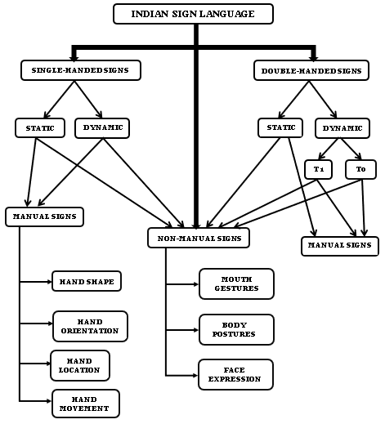

Fig. 1. Indian Sign Language hierarchy.

Single-handed signs are exhibited by a single dominant hand which could be either a static or a dynamic sign; static signs are those gestures where there is no motion of the hand but the dynamic signs are as the name suggests making a motion with your hand.

Double-handed signs are split into static and dynamic also further subdivided into **T1** and **T0** i.e., **Type1** and **Type0**. T1 signs use the dominant hand more than the non-dominant one and T0 is vice versa. Non-manual signs are those which are expressed without using hands instead of using facial expressions, body postures, or mouth gestures.

Non-manual signs are those which are expressed without using hands instead of using facial expressions, body postures, or mouth gestures.

# LITERATURE REVIEW AND PLANNING

The different parameters used in the comparison of facts are shown in Fig 2.Our blueprint for the literature review is comparing machine learning and deep learning techniques separately using isolated signs (single sign gesture)/ continuous signs (a sentence using ISL), no of signs, total dataset size, feature extraction technique to extract the hidden characteristics, classification technique to classify the data in the respective sign, and average accuracy of the model they have used. This paper’s main centre of attention is in Indian Sign Language (ISL), as we have only considered paper having keyword ISL from 2017-2021.

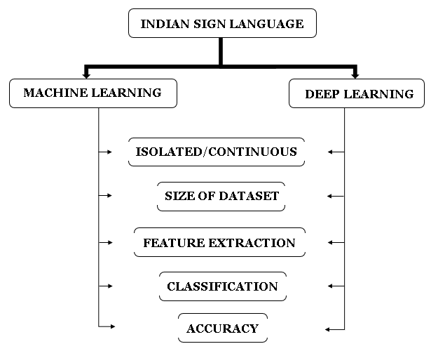

Fig. 2. Reviewing classification

# MACHINE LEARNING TECHNIQUES

Miss. Juhi Ekbote, Mrs. Mahasweta Joshi proposed “Indian sign language classification using Artificial Neural Network (ANN) and Support Vector Machine (SVM)” in 2017. They have collected 10 isolated single-handed signs (0 to 9 numerals) and extracted the features using Shape descriptors, Scale Invariant Feature Transform (SIFT), and Histogram of Oriented Gradients (HOG) and classified them using 2 classification algorithms Artificial Neural Network (ANN) and Support Vector Machine (SVM). The experimental results showed that both SVM and ANN had the same accuracy 93% [1].

Yogeshwar I. Rokade, Prashant M. Jadav proposed an “Indian sign language recognition system” in 2017. They have collected 26 isolated single and double-handed alphabetical signs and extracted features using Distance transformation, Discrete Fourier Transform, Probability distribution property that is central, and classified them using Artificial Neural Network (ANN) and Support Vector Machine (SVM). The experimental results showed that ANN outperformed SVM [2].

Sirshendu Hore, Sankhadeep Chatterjee, V. Santhi, Nilanjan Dey, Amira S. Ashour, Valentina Emilia Balas, and Fuqian Shi proposed “Indian Sign Language Recognition Using Optimized Neural Networks'' in 2017. They have collected 22 isolated single and double-handed gestures. They have extracted the features using a Genetic algorithm and Euclidean distance and classified them using K-nearest neighbor (KNN) and Euclidean distance. The experimental results show that the NN-PSO outperformed the other approaches with 99.96 accuracies, 99.98 precision, 98.29 recall, 99.63 F-Measure, and 0.9956 kappa statistics [3].

G. Ananth Rao, P.V.V. Kishore proposed “Selfie video-based continuous Indian sign language recognition system” in 2018. They have collected 50 continuous single-handed signs. They have extracted the features using Sobel adaptive threshold, Morphological differencing and for classification, the models used are Minimum Distance, Artificial Neural Network. The results show that ANN outperformed with 90% accuracy [4].

Kartik Shenoy, Tejas Dastane, Varun Rao, Devendra Vyavaharkar proposed “Real-time Indian Sign Language (ISL) Recognition” in 2018. They have collected 33 hand poses and 12 gestures isolated and continuous using single-hand and double-hand. The feature extraction techniques used are Grid-based Feature Extraction, Feature Vector, Histogram of Oriented Gradients (HOG) and the classification model used is k-Nearest Neighbours algorithm (KNN), Hidden Markov Model (HMM). Results show an accuracy of 99.7% for static hand poses, and an accuracy of 97.23% for gesture recognition [7].

Muthu Mariappan H, Dr. Gomathi V proposed “Real-Time Recognition of Indian Sign Language” in 2019.

They have collected 80-word signs and 50 continuous sentences for their dataset using both single and double hands for feature extraction they have used orientation histogram, eigenvector-based technique, and classification technique used is eigenvalue weighted euclidean distance technique. The classification accuracy rate thus obtained is 86% [8].

P.K. Athira, C.J. Sruthi, A. Lijiya proposed “A Signer Independent Sign Language Recognition with Co-articulation Elimination from Live Videos: An Indian Scenario” in 2019. They have collected 46 isolated and

TABLE 1. MACHINE LEARNING TECHNIQUES

continuous signs using single-hand and double-hand; extracted the features using Histogram of Orientation Gradient (HOG), Histogram of Edge Frequency (HOEF), Zernike moments, the classified using Support Vector Machine (SVM). Experimental results show that SVM has produced an accuracy of 92.88% [10].

T Raghuveera, R Deepthi, R Mangalashri, And R Akshaya proposed “A depth-based Indian Sign Language recognition using Microsoft Kinect” in 2020. They have collected 140 unique isolated and continuous gestures using single-hand and double-hand. Feature extraction has been done by Speeded Up Robust Features, Histogram of Oriented Gradients, and Local Binary Patterns; the classifier algorithm used is Support Vector Machine (SVM). Experimental results state that the model produced an accuracy up to 71.85% [12].

Purva Chaitanya Badhe, Vaishali Kulkarni proposed “Artificial Neural Network based Indian Sign

Language Recognition using handcrafted features'' in 2020. They have collected 46 different continuous signs using single and double hand; for feature extraction the techniques used are HOG, Principal Curvature Based Region (PCBR), and Wavelet Packet Decomposition (WPD), Principal Component Analysis (PCA), or Scale Invariant Feature Transform (SIFT). The classification technique used is Artificial Neural Network (ANN) and after rigorous work secured training accuracy 98%, validation accuracy 63% [13].

# DEEP LEARNING-BASED TECHNIQUES

G.Anantha Rao, K.Syamala, P.V.V.Kishore, A.S.C.S.Sastry proposed “Deep Convolutional Neural Networks for Sign Language Recognition” in 2018. They have collected 200 continuous sign images using single and double hands and the classification they have used is Convolution Neural Network (CNN) having four convolutional layers, two stochastic pooling layers, and Softmax regression. Experimental results

show that it possesses an accuracy of 92.88% recognition rate [5].

Sajanraj T D, Beena M V proposed “Indian Sign Language Numeral Recognition Using Region of Interest Convolutional Neural Network” in 2018. They have collected 36 isolated single and double-handed signs; the classification model used is Convolution Neural Network (CNN), HSV

color space with Contrast Limited Adaptive Histogram Equalization (CLACHE). The experiment produced an

accuracy of 99.56% and 97.26% in the low light condition [6].

Ankita Wadhawan, Parteek Kumar proposed a “Deep learning-based sign language recognition system for static signs” in 2019. They have collected 100 static continuous signs using single and double hands; the model used by them is Convolution Neural Network (CNN) with max-pooling. The experiment results in the highest training accuracy of 99.72% and 99.90% on colored and grayscale images [9].

Neel Kamal Bhagat, Vishnusai Y, Rathna G N proposed “Indian Sign Language Gesture Recognition using

Image Processing and Deep Learning” in 2019. They collected 36 isolated static gestures, 10 dynamic signs using single and double-hands the classification model used is Convolution Neural Network (CNN), Long Short-Term Memory (LSTM), Connectionist temporal classification, and Handcrafted feature techniques like Scale Invariant Feature

Transform (SIFT), s Gradient Hough Transform (GHT). The experiment produced an accuracy of 97.71% [11].

R. Dhiman, G. Joshi, and C. Rama Krishna proposed “A deep learning approach for Indian sign language gestures classification with different backgrounds” in 2021. They have collected 15 isolated signs using single and double hands; the classification model used is Convolution Neural Network (CNN) models softmax layer with optimization techniques (Adam, Sgdm, RMSProp), activation functions

(ReLU and Leaky ReLU). The accuracy obtained for NUS

TABLE 2. DEEPLEARNING-BASED TECHNIQUE

dataset-I, NUS dataset-II, and the mixed dataset is 100%, 95.95%, and 97.22% [14].

Adithya Venugopalan, Rajesh Reghunadhan proposed “Applying deep neural networks for the automatic recognition of sign language words: A communication aid to deaf agriculturists” in 2021. They have collected 9 continuous double-handed gestures; the classification model used is a convolutional neural network (CNN), GoogleNet, and bidirectional LSTM (BiLSTM) sequence network. The assessment produced an average classification accuracy of 76.21% [15].

# OVERALL OBSERVATIONS

Analyzing the data of ISL from 2017 to 2021as shown in Fig. 3 it is seen that in 2018 and 2019 the most papers were published and in 2021 the least papers were published.

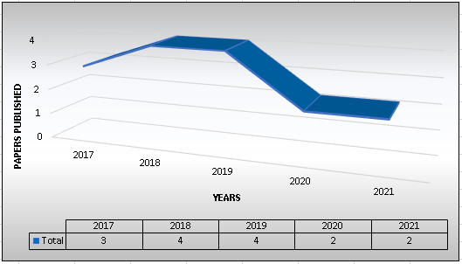

Fig. 3. Trendline of papers published over the years.

From the data summary, it is seen that both isolated and continuous signs are both used equally over the years but both combined are not used much as shown in Fig. 4.

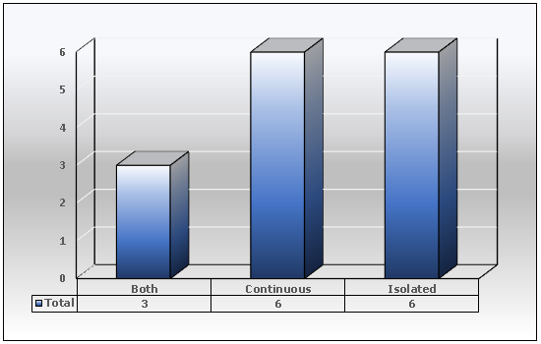

Fig. 4. Research work carried out on isolated and continuous signs.

The datasets used mostly by people have both single-handed and double-handed signs in them having both static and dynamic gestures as shown in Fig. 5.

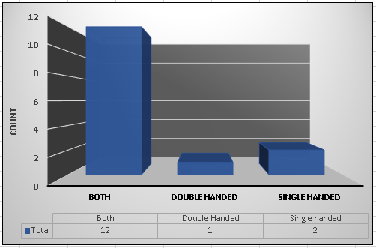

Fig. 5. Research Work carried out on Single/Double Handed Signs

A pie-chart representation of all the classification techniques used by different peoples working on ISL recognition and it is seen that the CNN model is used the most in deep learning techniques the classification accuracy it's getting is more than 96% in the all above studies and ANN is used the most for machine learning techniques and the accuracy it is generating is more than 90%. So, this clearly shows that the CNN model is better to be used as shown in Fig. 6.

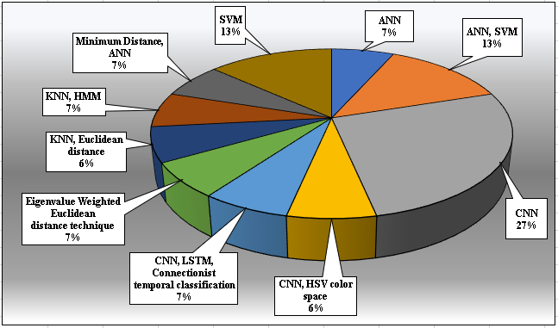

Fig. 6. Percentage of research work carried out on techniques used for recognition of signs.

# CONCLUSION

Indian sign language has a wide range of applications that would benefit the deaf and dumb community, this paper has seen multiple articles out of those that have selected 15 research articles published between 2017 and 2021. This aims to summarize based on Indian Sign Language categorized in isolated/ continuous, single/ double-handed gestures, signs, total dataset size, feature extraction technique, classification technique, and accuracy. This paper provides a considerable amount of information for anyone to kick-start their work without having to redo the work; the results thus obtained are as follows:

* It is seen that in the years of research that in the year 2018 and 2019 most papers were published and after that, the number of papers published has decreased and people have started researching using deep-learning techniques more frequently than using machine-learning techniques which were used in the past.
* The dataset used by most researchers is created by themselves recorded using a camera or a mobile phone using both single hands and double hands isolated and continuous, the majority of the people have used both single and double-handed gestures for their dataset.
* Results state that deep-learning techniques like CNN have produced a better feature extraction and classification in the experiments and the accuracy produced is more than 95% which is outstanding while most machine-learning techniques produced less accuracy.

With emerging technologies and advancements over the years, one thing is for sure that though people would be born deaf and dumb they won’t feel like being born with a disability and would be able to communicate freely and independently without having to rely on anyone what more could they ask for.

##### Acknowledgment

We are very grateful to the staff at Computer Science and Engineering lab of Lovely Professional University for their continuous support. We would specially thank our project mentor Ankita Wadhawan for her valuable contribution at various stages of the research.

##### References

1. Ekbote, Juhi, and Mahasweta Joshi. "Indian sign language recognition using ANN and SVM classifiers." In 2017 International conference on innovations in information, embedded and communication systems (ICIIECS), pp. 1-5. IEEE, 2017.
2. Rokade, Yogeshwar I., and Prashant M. Jadav. "Indian sign language recognition system." International Journal of engineering and Technology 9, no. 3 (2017): 189-196.
3. Hore, Sirshendu, Sankhadeep Chatterjee, V. Santhi, Nilanjan Dey, Amira S. Ashour, Valentina Emilia Balas, and Fuqian Shi. "Indian sign language recognition using optimized neural networks." In Information technology and intelligent transportation systems, pp. 553-563. Springer, Cham, 2017.
4. Rao, G. Ananth, and P. V. V. Kishore. "Selfie video based continuous Indian sign language recognition system." Ain Shams Engineering Journal 9, no. 4 (2018): 1929-1939.
5. Rao, G. Anantha, K. Syamala, P. V. V. Kishore, and A. S. C. S. Sastry. "Deep convolutional neural networks for sign language recognition." In 2018 Conference on Signal Processing And Communication Engineering Systems (SPACES), pp. 194-197. IEEE, 2018.
6. Sajanraj, T. D., and M. V. Beena. "Indian sign language numeral recognition using region of interest convolutional neural network." In 2018 Second International Conference on Inventive Communication and Computational Technologies (ICICCT), pp. 636-640. IEEE, 2018.
7. Shenoy, Kartik, Tejas Dastane, Varun Rao, and Devendra Vyavaharkar. "Real-time Indian sign language (ISL) recognition." In 2018 9th International Conference on Computing, Communication and Networking Technologies (ICCCNT), pp. 1-9. IEEE, 2018.
8. Mariappan, H. Muthu, and V. Gomathi. "Real-time recognition of Indian sign language." In 2019 International Conference on Computational Intelligence in Data Science (ICCIDS), pp. 1-6. IEEE, 2019.
9. Wadhawan, Ankita, and Parteek Kumar. "Deep learning-based sign language recognition system for static signs." Neural Computing and Applications 32, no. 12 (2020): 7957-7968.
10. Athira, P. K., C. J. Sruthi, and A. Lijiya. "A signer independent sign language recognition with co-articulation elimination from live videos: an indian scenario." Journal of King Saud University-Computer and Information Sciences (2019).
11. Bhagat, Neel Kamal, Y. Vishnusai, and G. N. Rathna. "Indian sign language gesture recognition using image processing and deep learning." In 2019 Digital Image Computing: Techniques and Applications (DICTA), pp. 1-8. IEEE, 2019.
12. Raghuveera, T., R. Deepthi, R. Mangalashri, and R. Akshaya. "A depth-based Indian sign language recognition using microsoft kinect." Sādhanā 45, no. 1 (2020): 1-13.
13. Badhe, Purva Chaitanya, and Vaishali Kulkarni. "Artificial Neural Network based Indian Sign Language Recognition using hand crafted features." In 2020 11th International Conference on Computing, Communication and Networking Technologies (ICCCNT), pp. 1-6. IEEE, 2020.
14. Dhiman, R., G. Joshi, and C. Rama Krishna. "A deep learning approach for Indian sign language gestures classification with different backgrounds." In Journal of Physics: Conference Series, vol. 1950, no. 1, p. 012020. IOP Publishing, 2021.
15. Venugopalan, Adithya, and Rajesh Reghunadhan. "Applying deep neural networks for the automatic recognition of sign language words: A communication aid to deaf agriculturists." Expert Systems with Applications 185 (2021): 115601.